**Automobile Dashboard Report**

**By- Auto-Techies**

**Aditya Singh Kushwaha (055063)**

**Harry Garg (055085)**

**1. Overview**

The automobile dashboard provides a detailed analysis of various parameters that influence car performance, pricing, and efficiency. By analysing key factors such as engine size, horsepower, fuel type, vehicle weight, and wheelbase, the dashboard helps in identifying industry trends and correlations. The insights from this report can assist car manufacturers, buyers, and analysts in making informed decisions.

**2. Key Insights and Analysis**

**2.1 Car Brands and Fuel Type Distribution**

* The dashboard categorizes different automobile brands based on the fuel type they use.
* This helps in understanding which brands focus on petrol, diesel, or alternative fuel sources like electric or hybrid technology.
* Analysing this data provides insights into fuel consumption trends and how automobile manufacturers are adapting to environmental regulations and sustainability goals.

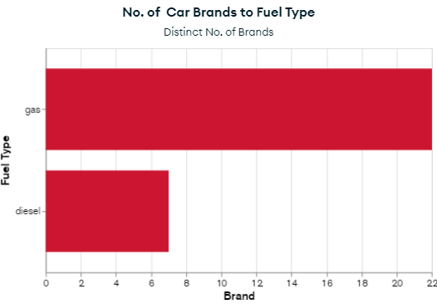

**2.2 Engine Size by Brand**

* The dashboard evaluates the average engine size for various car brands.
* Some brands may prioritize smaller, fuel-efficient engines, while others may focus on larger engines for high performance.
* 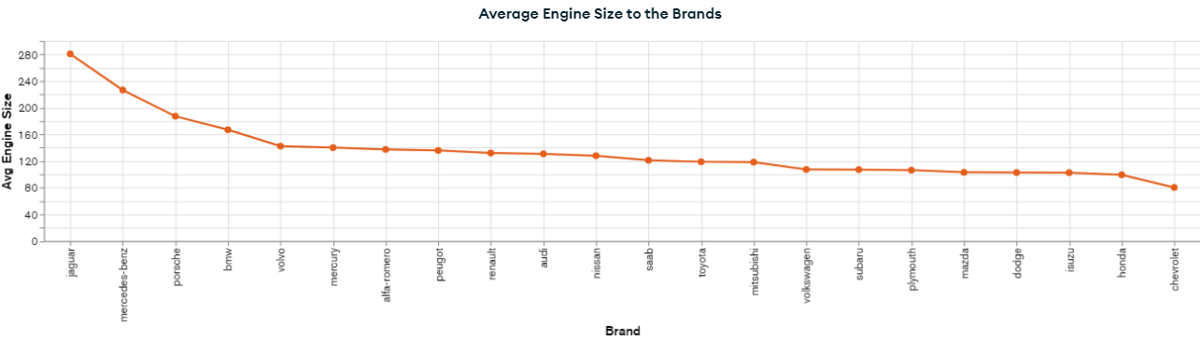Understanding engine size trends helps in determining a brand’s market positioning—whether they focus on economic, luxury, or sports vehicles.

**2.3 Engine Placement (Front vs. Rear)**

* The data presents insights into whether engines are placed at the front or rear of a vehicle.
* Most vehicles have front-engine placement, which offers better stability and efficiency. However, sports and high-performance cars often use rear-engine placement for better weight distribution and handling.
* The distribution of engine placement provides insights into vehicle design and performance attributes.

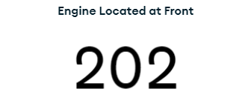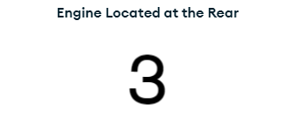

**2.4 Car Body Type and Price Analysis**

* This section highlights how the average price of a vehicle varies with different body types such as sedan, hatchback, SUV, coupe, or convertible.
* Larger vehicles like SUVs and luxury sedans tend to have higher price tags compared to compact hatchbacks.
* 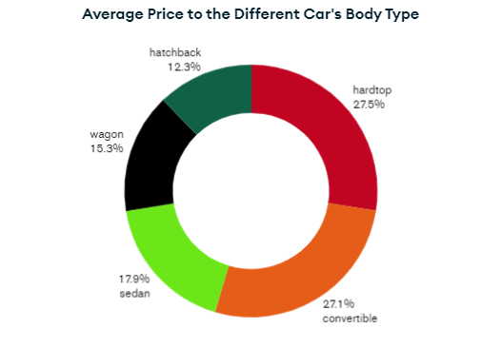The analysis helps manufacturers and consumers understand the price range associated with each body style.

**2.5 Horsepower Comparison (Turbo vs. Standard Engines)**

* The dashboard compares the horsepower of vehicles equipped with turbocharged engines versus those with standard engines.
* Turbo engines typically produce more power while maintaining fuel efficiency, making them popular in sports and performance cars.
* The data can help consumers decide whether they need a turbo engine for enhanced performance or if a standard engine meets their requirements.

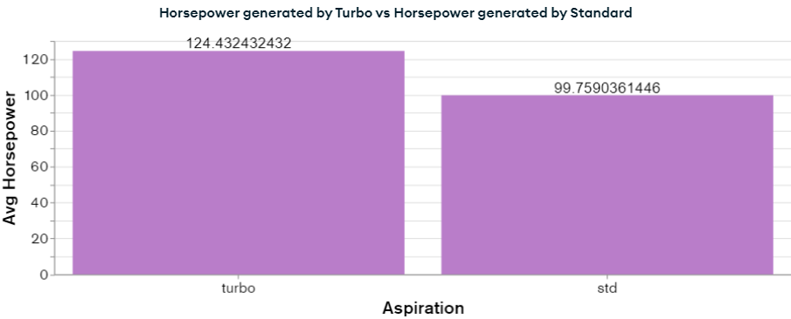

**2.6 Correlation Between Engine Size and Price**

* This analysis explores the relationship between a vehicle’s engine size and its price.
* Typically, larger engines with more cylinders tend to be more expensive due to increased power output and advanced engineering.
* 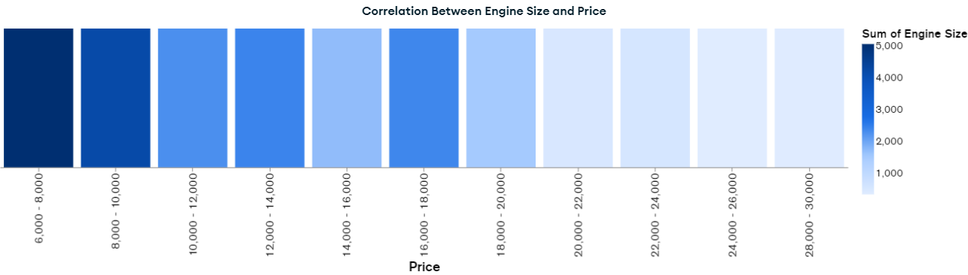A clear correlation between engine size and pricing can assist buyers in making cost-effective choices based on their performance needs.

**2.7 Fuel Efficiency vs. Engine Size**

* A crucial factor in automobile performance is the trade-off between engine size and fuel efficiency.
* Larger engines generally consume more fuel, reducing mileage, while smaller engines offer better fuel economy.
* This analysis helps consumers understand how engine size impacts their fuel expenses over time.

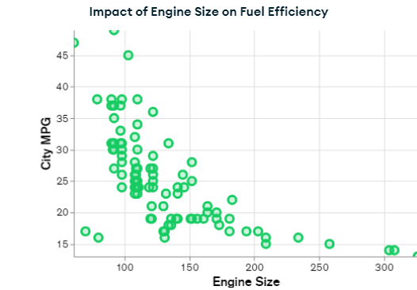

**2.8 Weight Influence on Highway Mileage**

* The dashboard evaluates how the weight of a vehicle affects its highway fuel economy.
* Heavier cars, such as SUVs and trucks, generally consume more fuel than lighter vehicles like sedans and hatchbacks.
* 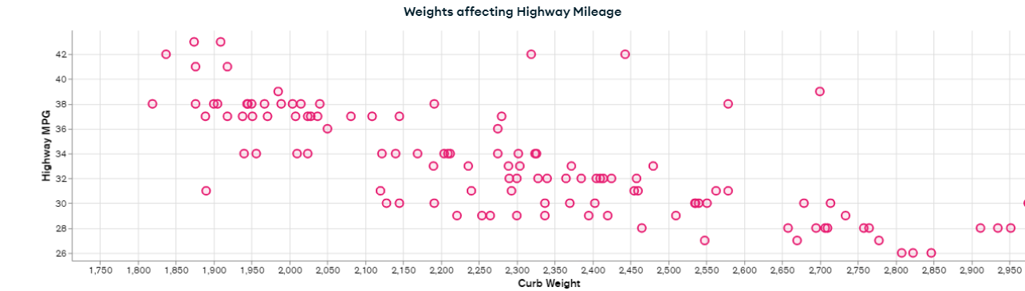Understanding this relationship helps manufacturers in designing vehicles with better weight distribution and fuel efficiency.

**2.9 Drive-Wheel Type and Fuel Type by Brand**

* Vehicles are categorized based on their drive-wheel configuration: Front-Wheel Drive (FWD), Rear-Wheel Drive (RWD), or All-Wheel Drive (AWD).
* Different brands adopt various drive-wheel configurations based on performance, terrain suitability, and cost factors.
* 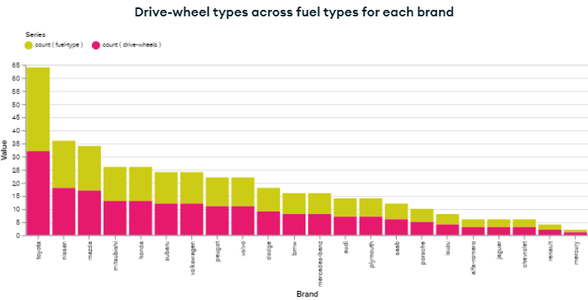The dashboard also explores the relationship between drive-wheel type and fuel efficiency, helping buyers choose the right drivetrain for their needs.

**2.10 City MPG and Engine Types**

* The analysis of city miles per gallon (MPG) across different engine types helps consumers determine fuel efficiency in urban environments.
* Smaller engines typically perform better in city driving, while larger engines may be more suited for highways.
* This information is beneficial for urban commuters who prioritize mileage over power.

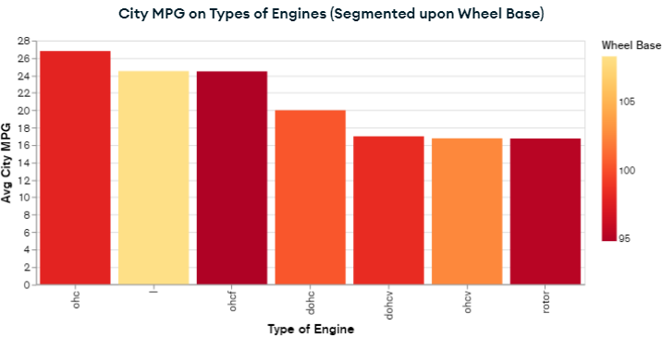

**2.11 Compression Ratio and Engine Size by Fuel Type**

* The compression ratio of an engine affects its efficiency and performance.
* The dashboard compares compression ratios across different engine sizes and fuel types.
* 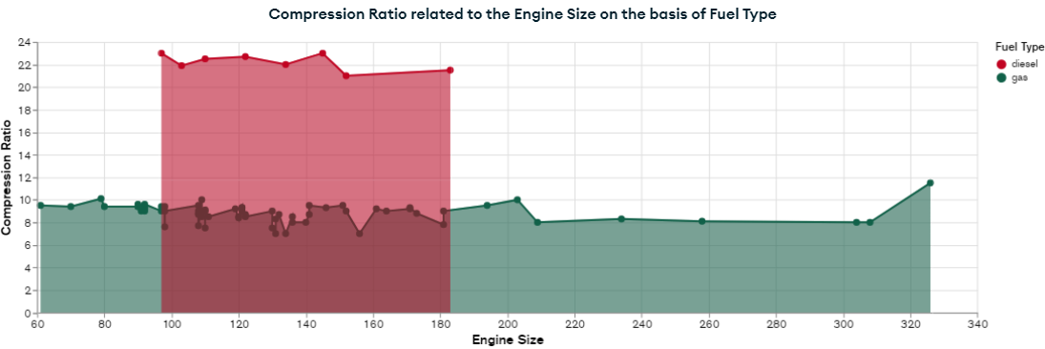Higher compression ratios generally indicate better fuel efficiency but require higher-octane fuel, making this an important factor for performance car enthusiasts.

**2.12 Market Average Car Price**

* The dashboard provides an overview of the average car price in the market.
* This information helps in setting realistic pricing expectations for new buyers and enables manufacturers to position their vehicles competitively.
* By comparing average prices across various segments, consumers can decide which category of vehicle fits their budget.

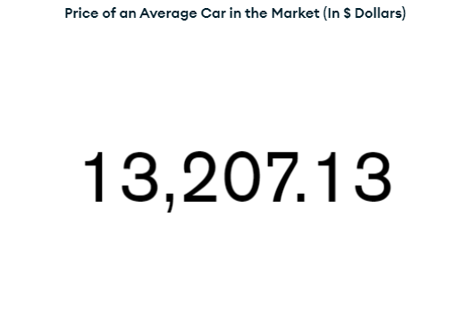

**2.13 Maximum Wheelbase on Roads**

* The analysis presents the maximum wheelbase of vehicles currently in use.
* A longer wheelbase generally translates to a smoother ride and more cabin space, which is preferred in luxury sedans and SUVs.
* Understanding wheelbase trends helps manufacturers design cars that balance comfort, stability, and manoeuvrability.

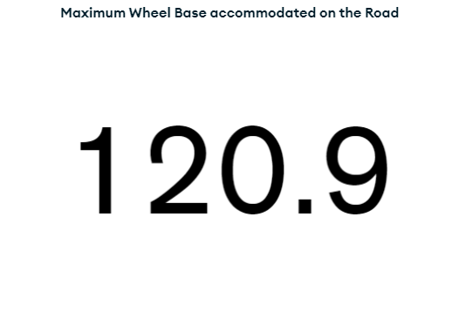

**2.14 Median RPM Across Automobiles**

* The dashboard calculates the median revolutions per minute (RPM) across different automobile models.
* RPM indicates how hard an engine is working at a given speed.
* 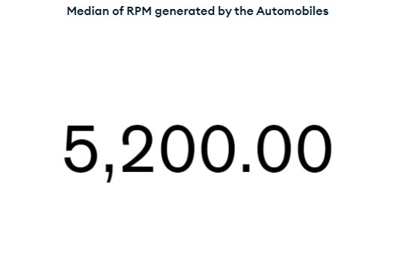A balanced RPM ensures efficient fuel consumption and smooth driving performance.

**3. Conclusion**

This automobile dashboard provides a comprehensive overview of the automotive industry, helping stakeholders understand trends in fuel efficiency, pricing, engine performance, and vehicle design.

* **For manufacturers:** The insights can guide design choices, marketing strategies, and pricing models.
* **For consumers:** The data helps in making informed decisions about purchasing vehicles based on their needs.
* **For analysts:** The dashboard serves as a valuable tool for identifying industry trends and predicting future developments.